**JavaScript Day 2(10-09-24)**

J. Rahul Yadav

**1.What is Parser ?**

A **parser** is the module of a compiler or interpreter that parses a source code file.

More generally, it's a piece of software that parses text and transforms its content to another representation.

In, JavaScript parser task is to **separate** the program into **tokens** for the further process.

**2.What is AST(Abstract Syntax Tree) ?**

It is a **tree data structure representing** any structured text file, so every standardized syntax can be represented through an **AST**.

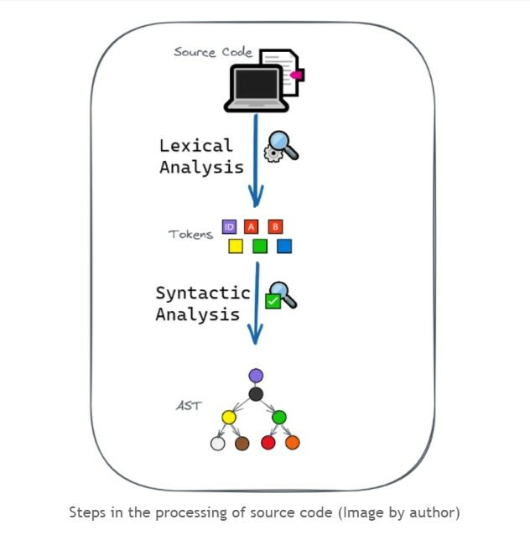

**3.What is Interpreter ?**

**Interpreter** is a program which **runs** and **executes** the source code .

What makes it **different** form compiler is that it **execute** the code **line-after-line.**

**4.What is JIT Compiler ?**

compiler is not like the Interpreter which makes line-by-line execution. Although the **job** of both are **execute** the code but what differ **compiler** from **interpreter** is that it executes the whole **code at time or whole file at a time**.

Both has its Pros and Cons but when we combine them and use we make the most out of it.

**5.Machine Code vs Byte code vs Source Code?**

**Machine code:** Machine code is a numerical language or binary language representation of the Source code.

**Byte Code:** In the programming languages like **Java**, **C++** when the code is **executed** we directly not get the output

* **Let’s take an Example**

In **Java** when the code is executed the source code is converted to **the .class file**(byte code) by using a compiler called (**java c** ) , which can be executed in any system where **JDK** is Installed.

In **C++** when the code is executed the source code is converted to the **.exe** file by using a compiler, where it can be executed **only** in that computer.

**Source Code:**Whatever **program** or **instructions** given by **us** in a particular Language(Prog) is called as source code.

**8.What is Web API?**

API stands for **Application Programming Interface**

It is a framework that helps you to create and develop HTTP based RESTFUL services. The web API can be developed by using different technologies such as java, ASP.NET, etc. Web API is used in either a web server or a web browser. Basically Web API is a web development concept. It is limited to Web Application’s client-side and also it does not include a web server or web browser details. If an application is to be used on a distributed system and to provide services on different devices like laptops, mobiles, etc then web API services are used. Web API is the enhanced form of the web application.

**7.Explain About Stack and Heap Memory ?**

The data is **stored** in two memory one is **Stack** and other one is **Heap.**

This is how the Stack and Heap Memory looks like:

**Heap**

**Stack**



Let’s Take and example how it will store a variable called (a = 10;)

**Heap**

**Stack**

10

a



The value 10 (object) is stored in the heap memory which have reference variable a pointing toward it

**a** is the reference variable that is **pointing** towards the **object** stored in the heap memory   
  
**note:** a is not storing the value 10 it is pointing towards the value 10 which is stored in the heap memory

**6.What is Differences Between Compiler and interpreter ?**

